Talking About Sexism, Misogyny, and Gender-Based Violence
with Truth, Lies, and the Questions in Between

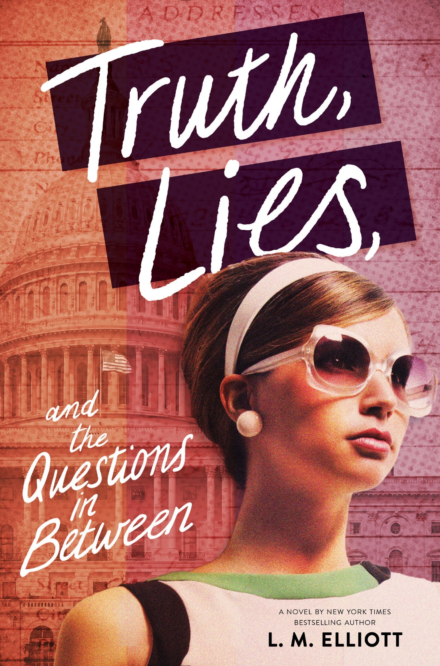

DISCUSSION GUIDE

ABOUT THE BOOK AND THIS GUIDE

L.M. Elliott’s historical novel, Truth, Lies, and the Questions in Between, explores major events of the year 1973 — the Watergate hearings, the Equal Rights Amendment, Roe v. Wade, and the Vietnam War — through the eyes of fictitious, 18-year-old Patty Appleton. Patty, one of the U.S. Senate’s first female Congressional Pages, has never been away from her Illinois home before and the influences of her conservative parents and her politically ambitious boyfriend Scott. On her own in Washington, DC, Patty encounters diverse perspectives, makes new friends who voice views different from hers, and observes what is happening in the world around her, slowly opening her eyes to the realities of political corruption and society’s treatment of Vietnam veterans, Black Americans, and women. Seizing the chance to discover who she wants to be, Patty begins to question her previous beliefs and develop her own ideas about politics, love, loyalty, a woman’s role in society, and so much more.

Woven through Patty’s story are her experiences with the social systems and environments of the era that continue today: misogyny, sexism, sexual harassment, sexual assault, and rape culture.

Every 68 seconds, someone in the United States is sexually assaulted. One third of American college women will experience Intimate Partner Violence. Yet, guidance and conversation starters that help young people build collective understanding of what consent means, how to have healthy relationships, and develop respect for boundaries are scattered and scarce. Truth, Lies, and the Questions in Between can provide a springboard for discussion that allows young people to talk and learn about these issues, confront gender-based degradation, gain compassion, take responsibility, and break stereotypes.



This discussion guide can be used for student reflections or classroom or book club conversations. To prepare for facilitating an open conversation on sexual harassment, gender-based violence, consent, and rape culture, you should first:

- Educate yourself on the facts about sexual assault and how to both seek and offer support.
- Take time to first evaluate your own beliefs and experiences, looking for privilege or blind spots, and focus on how to apply an intersectional lens to discussions.
- Create a safe space that maintains a respectful and supportive environment where readers can share their perspectives and questions. Ask your school counselor, school psychologist, and/or other wellness staff to attend as support.
- Consider how certain discussions of behaviors, attitudes, and experiences might be distressing for some readers, either due to their personal experiences or because such dialogue forces them to confront deeply held beliefs, biases, or worldviews.
- Fully understand any duty to report possible disclosures of sexual assault from students to institutional authorities or directly to local social services or law enforcement.

DISCUSSION QUESTIONS

Before beginning, be sure participants understand that they don’t have to share anything they feel is too personal or private. Have clear discussion guidelines that assure everyone that the conversation will be respectful, empathetic, and confidential. You should also have participants work together to clearly define some terms, including sexual harassment, sexual assault, and rape culture. Know that every question here does not have to be raised in order to launch a beneficial discussion.

- Why do you think Simone offers Patty her copy of Our Bodies, Ourselves: A Book by and for Women? How do you think today’s sex education is different from what women and men were taught in the 1960s
and 70s?

- Patty’s parents, their social circle, and her all-girls parochial school inculcated Patty to believe women should not be opinionated or “nosy,” and be both complementary and complimentary to men. Her father tells her (p. 193), “A little knowledge is a good thing for a woman. But charm? Charm coupled with good looks? That's the killer combo, princess.” How does trying to live up to all this affect Patty? Do you think Patty feels respected in her experiences or relationships with boys? Why or why not? How does that change over the course of the book? What things can help both people in a relationship or in a conversation feel treated like they have value?

- How are the messages Patty gets from her family different or similar to what Simone gets from her family? How do these messages affect Patty and Simone sense of worth and self-definition?

- What kinds of things happen in Scott and Patty’s relationship or her parents’ marriage that make you uncomfortable? What signs of unhealthy or abusive relationships do you find in the book? What examples of healthy relationships, romantic or otherwise? Why do you consider these relationships healthy?

- How do 1973’s cultural forces and then-legal discrimination against women affect Patty’s place in the page program and in society? How do societal and cultural forces still affect women? What role stereotypes did you recognize in the book as still affecting girls and women today?

- Throughout the book, Patty is presented different ideas of femininity and women’s place in society and relationships—from Simone quoting feminist Nora Ephron’s criticism of male/female stereotyping of each other to Patty feeling she should emulate Marilyn Monroe’s smile which a male biographer eulogized as inspiring “all manner of dreams” in a man. How did these messages affect characters’ concepts of identity, sexuality, and love? What do young people today learn from mainstream and social media about sexuality and its relationship to identity and to respect? What influence do these messages have on attitudes toward women and on the way men and boys think about their own sexuality?

- Patty’s father dismisses his wife and her “annoying histrionics” (p. 85), and calls other women, including his female patients, “crazy.” How do such labels impact violence against women? What type of education or measures do you think it would take for Patty’s father, Scott, or Jake to reform their views and behavior toward women? Compare those characters’ attitudes with those of Will, Abe, Julius, and Simone’s dad.

- Both Patty’s father and Jake “gaslight,” defined as psychological manipulation used to gain power or control over others, by sowing doubt in their judgment and sense of self-worth. How does that affect Patty and her mother and their feeling the right to think for themselves and stick up for themselves?

- After sharing her ChapStick, Patty overhears some of the male pages snickering, “Wonder what else she has hidden in her coat that tastes like cherry.” (p. 7) How does that make Patty feel and react? How would you feel and react? Do you think Patty recognizes what happened as sexual harassment? What other instances of sexual harassment can you identify in the book? Has something similar happened to you, from peers or adults in authority/power? How did you feel? What type of things that you see or hear at school would be considered this type of harassment? How can sexual harassment be stopped?

- Examining rape culture is essential to understanding the environment in which sexual violence occurs. In the Ladies Home Journal, Patty comes across “Defending Yourself Against Rape—an excerpt from Our Bodies Ourselves” which “went on to blame society’s tolerance of rape, its mistaken belief it was an act of extreme passion not an act of violence and domination, on pop cultural fascination with ‘sex and violence,’ now an American idiom like ‘love and marriage.’ Many newspapers, magazines, and movies encourage people to groove on sadism . . .” (p. 199) How is sexual violence normalized and rationalized in the media, popular culture, and society? What examples of rape culture do you recognize in the book? What other cultural influences perpetuate sexual violence? What does rape culture say about what society thinks of women and their rights and safety?

- The National Institute of Health (NIH) estimates that one-third of American college women will experience manipulation, coercion, and gender-based violence (sexual, physical, or mental) from someone they know, are dating, or love and trust. After Patty is sexually assaulted, she struggles with many feelings, including feelings of guilt, that prior physical contact with her boyfriend had allowed him to assume her consent—which it does not. What kind of myths about sexual assault would lead her to incorrectly believe she was responsible for what happened to her? How do these myths, rape culture, and victim-blaming persist today? What does consent in a healthy relationship look like? What would it mean to create a more consent-based society?

- Reading and discussing books such as Truth, Lies, and the Questions in Between is a great step in bringing awareness and change. Where do you see other opportunities for proactive conversation?

RESOURCES

National Sexual Violence Resource Center
nsvrc.org

RAINN (Rape, Abuse & Incest National Network)
rainn.org

SafeBAE
safebae.org

Find more resources for this book and other award-winning titles from L.M. Elliott at lmelliott.com.

Stop Sexual Assault in Schools
stopsexualassaultinschools.org

Students Against Sexual Harassment sashclub.org.

